12/03/24

Lesson 32

What really Matters in This Section

<https://www.canva.com/design/DAEXMibkysc/uO4KEygGGLG13bkHSnzbgQ/view#2>

Lesson 33

Navigating The Git Documentation

<https://git-scm.com/docs>

<https://git-scm.com/docs/git-commit>

This is where to find the command.

Lesson 34

Keeping Your Commits Atomic

I committed all those 4 files.

I did 2 separate commit instead of one larger commit.

This is good when you working with team or code review.

Lesson 35

Commit Messages: Present Or Past Tense?

<https://medium.com/@corrodedlotus/which-tense-should-be-used-on-a-git-commit-message-121cb641134b>

<https://www.danclarke.com/git-tense>

<https://www.quora.com/Which-tense-should-be-used-in-a-git-commit-message-past-present-and-why>

<https://stackoverflow.com/questions/3580013/should-i-use-past-or-present-tense-in-git-commit-messages>

Use present tense when dojng commit messages.

Lesson 36

Escaping VIM & Configuring Git’s Default Editor

The changes that I just made.

I save and quit.

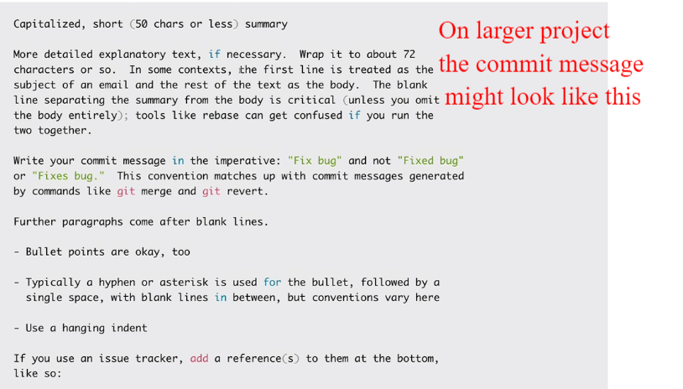

Multiple line, paragraph and bullet point.

<https://git-scm.com/book/en/v2/Appendix-C%3A-Git-Commands-Setup-and-Config>

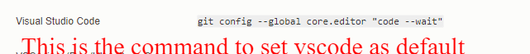

git config --global core.editor "code --wait"

What that wait means the git page need to open then wait while I type stuff inside the vscode. Once I closed the Vscode it automatically proceed as you can see below

But its taken soo much space. I will show you another command to minimize that.

Lesson 37

Closer Look At The Git Log Command

<https://git-scm.com/docs/git-log>

I want to explain the whole command

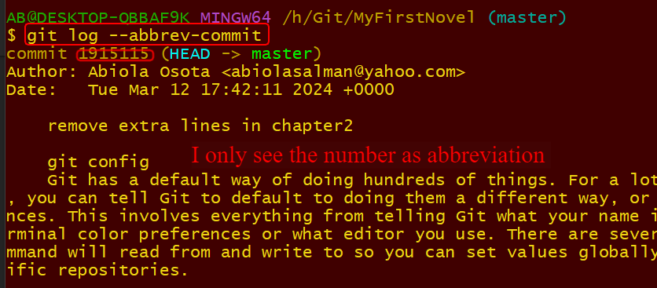

I need the online.

This summarise with this command

git log –-oneline

and

Lesson 38

Committing With A GUI

GitKraken

I open the same folder that I have been working with. MyFirstNovel. I use GitKraken then open a new repository which is the folder that I am working on.

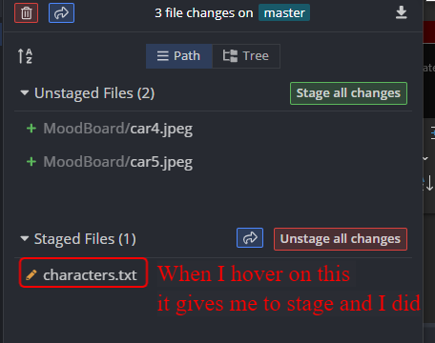

One file is stagged

Instead of git cracker, we have the salt or git tower etc.

Date 13/03/2024.

Lesson 39

Fixing Mistakes with Amend

4 files changed now while previously it was 3 as you can see below

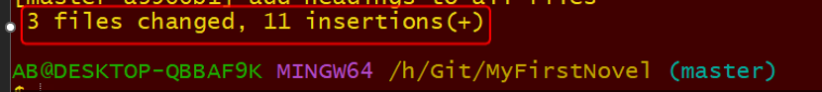

Just to show.

Lesson 40

Ignoring Files w/ .gitignore

<https://github.com/tensorflow/tensorflow>

<https://github.com/signalapp/Signal-Android>

<https://www.toptal.com/developers/gitignore>

<https://git-scm.com/docs/gitignore>

<https://docs.github.com/en/get-started/getting-started-with-git/ignoring-files>

Created the files

This is the lecturer page

